**Preferential Attachment Model:**

Up to now, we have looked at the degree of a node, however, sometimes we’re interested in the distribution of the degree over the whole network. This is known as the **degree distribution.**

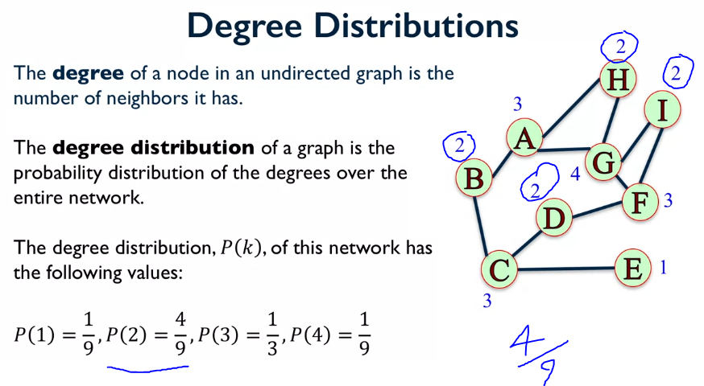

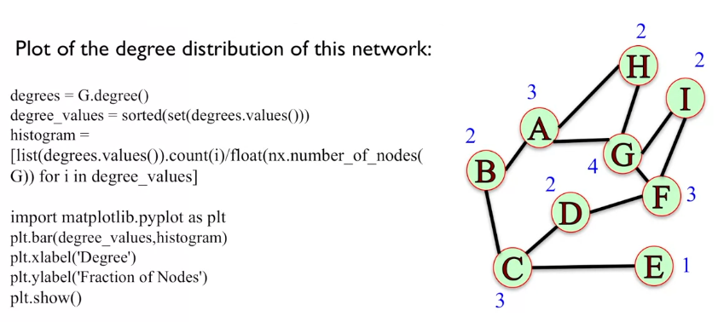

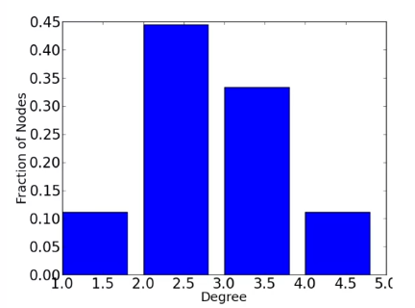

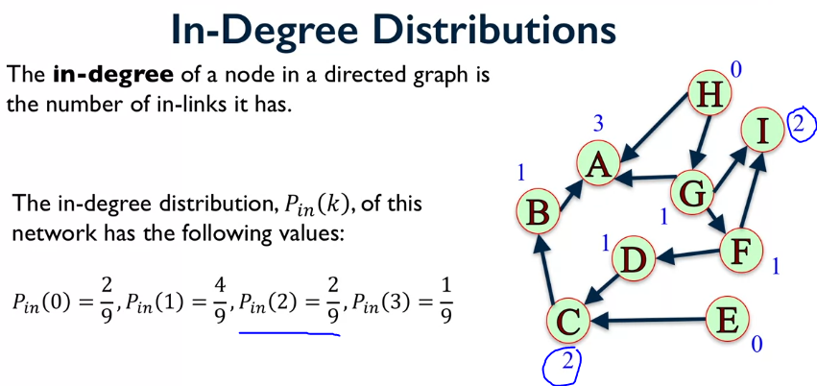

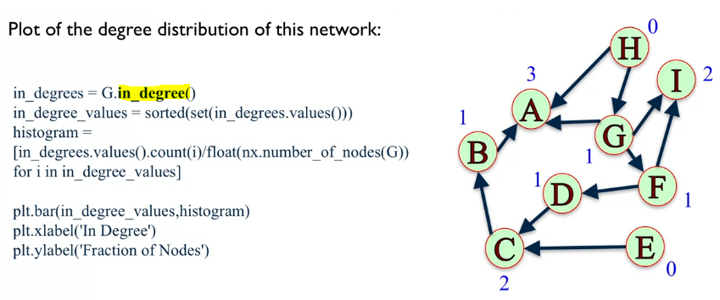

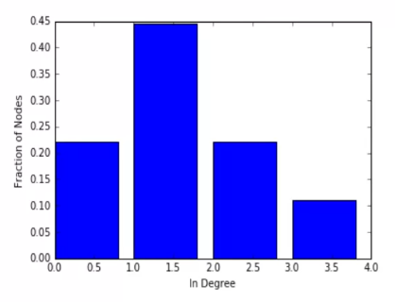

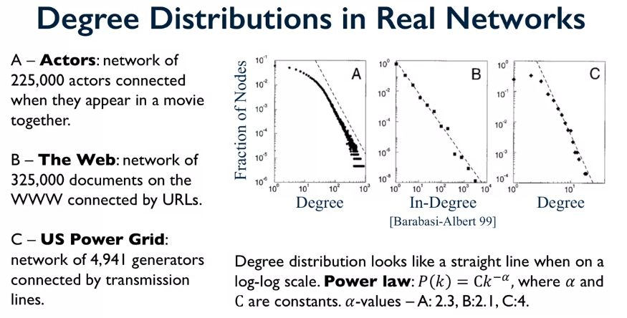

Networks with power law distributions have many nodes with small degree and few nodes with very large degree. This can be seen in figure A, the top left shows many nodes with small degree, and the bottom right shows few nodes with very high degree.

When we see such a strong pattern we want to try and explain what causes this patter to emerge? We try to answer this question by making models that generate networks with few assumptions about how these networks get creates. One model that does this is called the **Preferential Attachment Model.**

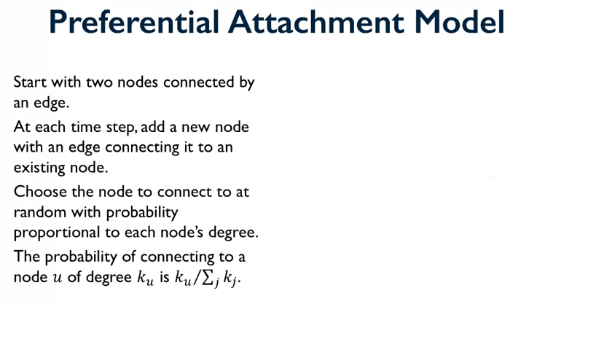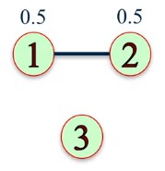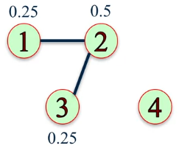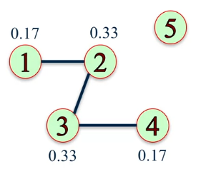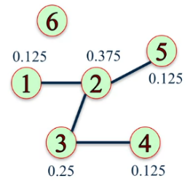

Looking at the diagrams on the right. The top left is a network of 2 nodes, and we want to add node 3 to the network, we compute the edge distribution and then use this as a probability of which node node 3 will connect to. We repeat this process until we are happy with the number of nodes.

The probability is calculated by summing up all the edges for each node and then dividing it by the number of edges on the node you’re interested in. e.g. for the bottom right network node 2: all the edges for all the nodes = 8 and node 2 has 3 edges, therefore, 3/8.

With this algorithm it has a tendency for the nodes with edges to gain more edges (like the rich get richer). This model produces a power law that is very similar to the real examples seen above.

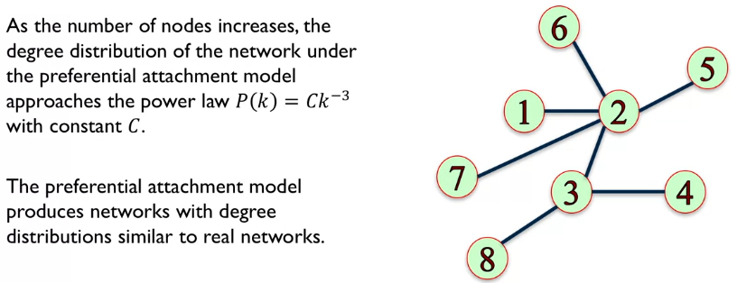

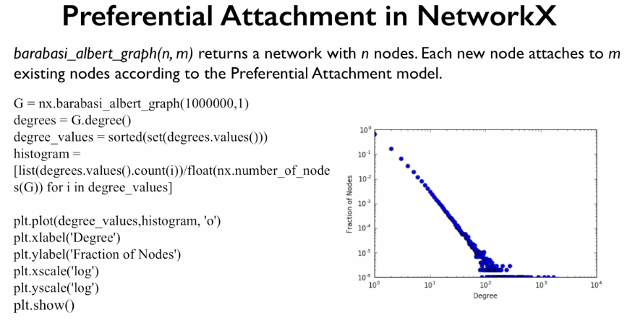

Where n is the number of nodes and m is the number of edges formed from the new node, in the above example we used m = 1.

